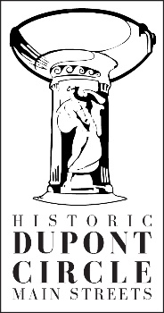
Social Media Assistance
Historic Dupont Circle Main Streets offers social media assistance for retail businesses (shops, restaurants, services, and museums) in Dupont Circle. This assistance grant is for consulting time (not for cash), is competitive, and will be offered until funds are expended by September 2018. Please fill out the form below, select which type of social media you desire, and return it to Historic Dupont Circle Main Streets. Thank you!

Name:
Business Name:
Address:
City: State: Zip:
Email: Phone:
______________________________________________________________________________
Social Media Needs (check all that apply):
- Yelp
- Instagram
- FaceBook
- Twitter
- Google +
- Google business page
- Trip Advisor
- Other:________________________________________
- Don’t know. Assess my business.
I need help with:
- Social media set up
- Social media training (my account(s) is already set up)
- Social media maintenance (I need assistance updating social media and creating a schedule)
- Social media photography and videos
- Don’t know. Help!

Return the completed form to:
Bill McLeod, Executive Director
Historic Dupont Circle Main Streets
9 Dupont Circle, NW
Washington DC 20036
execdirector@dupontcircle.biz
(202) 656-4487

