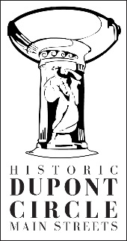

Membership
Historic Dupont Circle Main Streets is a 501 (c) (3) nonprofit organization, and we rely on your membership dollars to support all the things we do. For every $1 contributed to HDCMS, we are able to match it with $2 through grants, sponsorships, and ticket sales. Our focus recently has been on rat abatement, and we have partnered with the Department of Health, National Park Service, and key property owners to reduce the rat population. Your membership really makes a difference! Thank you!

Membership benefits include:
- Featured in the print newsletter that reaches 2000 people
- Featured in the e-blast newsletter to 1000 people
- FaceBook and Twitter posts about your business, reaching up to 1400 users
- Full business listing on our website, including a hyperlink to your website
- Free admission into the Spring Fling and other ticketed events
- Listed in the annual report, and
- Tax deductible donation letter.
And, of course our gratitude for supporting Historic Dupont Circle Main Streets! Thank you!!!
- - - - - - - - - - - - - - - - - - - - - - - - - - - - - - - - - - - - - - - - - - - - - - - - - - - - - - - - - - - - - - - - - - - - - - - - -

Name:____________________________________________________________________________

Business Name:____________________________________________________________________

Address:__________________________________________________________________________

City: ___________________________ State:_____________ Postal Code:__________________

Telephone:_______________________ email:___________________________________________

- $250 check is enclosed for a nonprofit organization
- $500 check is enclosed for a small business
- $1,000 check is enclosed for a large business
- Contact me about sponsoring an event

- My check is enclosed
- I would like to pay by credit card: _______________________ Exp._______ CVV:_____
Please mail your membership form with payment to:

Historic Dupont Circle Main Streets
9 Dupont Circle, NW
Washington, DC 20036

Questions? Contact Bill McLeod at execdirector@dupontcircle.biz or call (202) 656-4487.

Thank you for supporting Historic Dupont Circle Main Streets!

